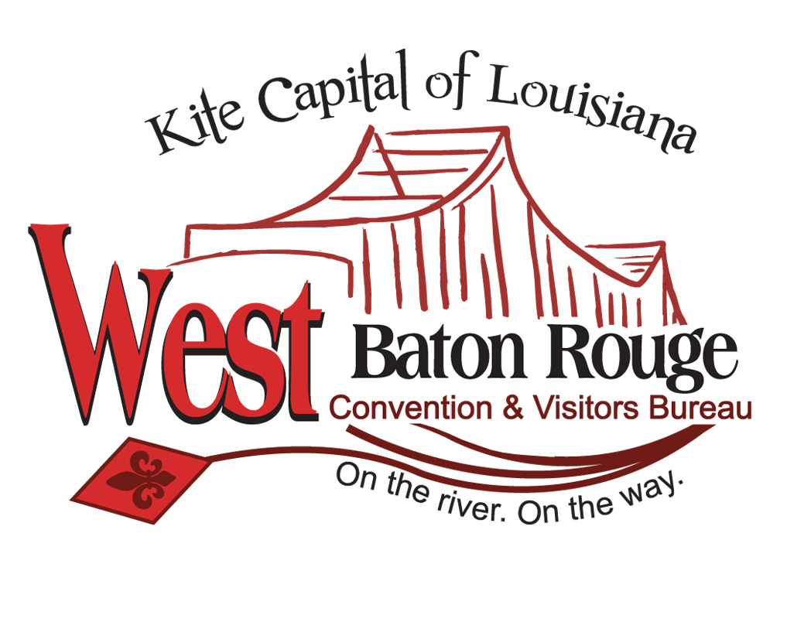Veterans on Parade Sponsorship Form 2023

Company Name: _____________________________

Contact Person: _____________________________

Company Address: ___________________________

City____________________State_____Zip________

Phone: (______) ___________-_________________

Email: _____________________________________

Sponsorship Amount: $_______________________
(Credit Cards Excepted for donations - $100 minimum )

Please mail Sponsorship form & check to:
West Baton Rouge CVB
2750 North Westport Drive
Port Allen, La 70767

For more information about sponsorship or to register your float please contact:

West Baton Rouge Convention & Visitors Bureau
225-344-2920
Lois lwebre@wbrcvb.com
Victoria vhughes@wbrcvb.com

